Link theme

<http://wpdemo.oceanthemes.net/lovus-planner/wedding-planner-2/>

link phân công công việc

<https://docs.google.com/spreadsheets/d/1VmyaX45sxUhk1sLTHY6DFftKlnLd-Yf7JgW1bkPqq78/edit#gid=0>

module 1: Giàu



Module 2: Giàu

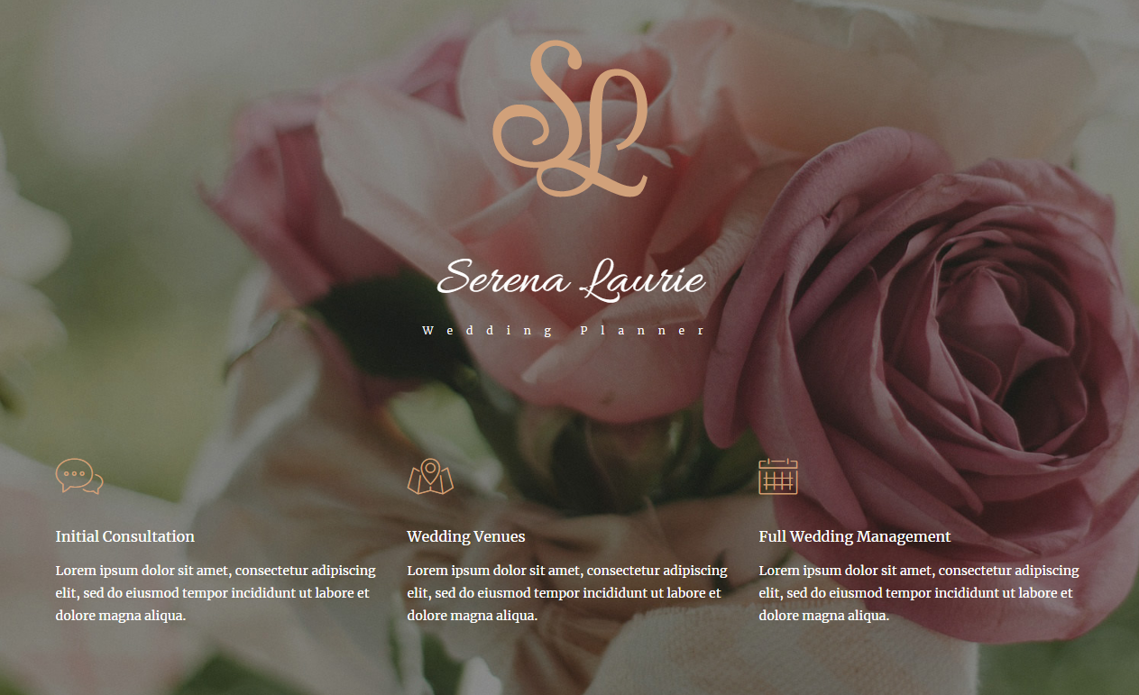

Module 3: Bữu



Module 4: chinh

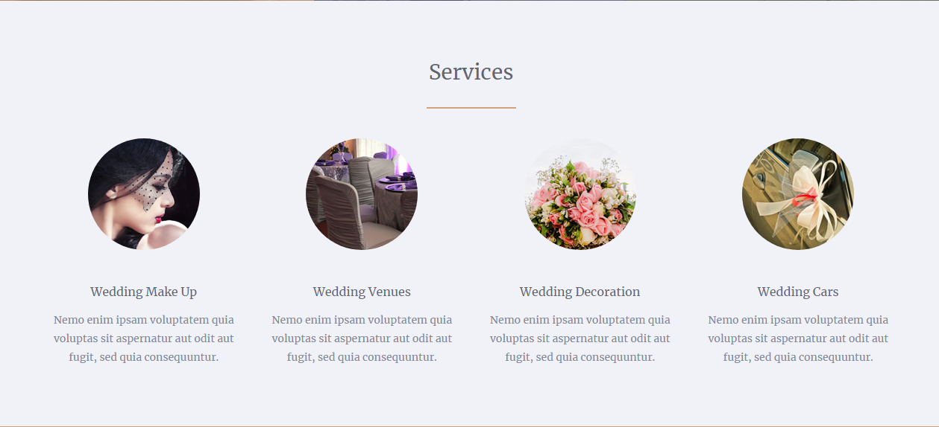

Module 5: Bửu



Module 6 : Chinh



Trang con:

Chinh : Services

Giàu: About

Bữu: Contact